

DECENTRALIZED FEDERATED LEARNING OVER IMPERFECT CHANNELS

PROJECT REPORT FINAL

Submitted by
RISHAV KUMAR MANJHI (24BAI0001)
ADITYA KUMAR SAHU (24BAI0128)
D. YASWANTH REDDY (24BCI0079)

Prepared For
COMPUTER NETWORKS (BCSE308L) - Project

Submitted To
Kalaavathi B

School of Computer Science and Engineering

Abstract

Federated learning (FL) enables privacy-preserving collaborative model training across distributed devices, but practical wireless deployments suffer from unreliable links characterized by random packet loss and asynchronous message delays. Existing gossip-based decentralized FL studies rarely quantify how network topology and channel impairments jointly affect convergence speed, consensus error, and communication cost. This work implements and evaluates a complete gossip-based decentralized FL framework over imperfect wireless channels, spanning three complementary methodologies. A CNN model is trained on MNIST across 5 virtual clients arranged in Ring, Grid, and Erdős–Rényi random graph topologies, under packet-loss rates of 0% and 20% over 20 gossip rounds. All topologies achieve approximately 99.1% test accuracy despite 20% packet loss. The Ring topology — with the highest spectral gap (γ = 0.461) — achieves a final consensus error of 0.121, which is 2.6× lower than the Grid topology (γ = 0.211, consensus error = 0.315). An event-triggered gossip protocol suppresses transmissions when the parameter change norm falls below a threshold δ, achieving up to 8% communication reduction with negligible accuracy loss (<0.03%). Spectral gap analysis theoretically predicts convergence speed and is validated empirically: higher spectral gap reliably corresponds to lower practical consensus error. These results confirm that gossip-based decentralized FL is robust to moderate packet loss, and that topology-aware protocol design guided by spectral gap can substantially reduce communication overhead in edge wireless networks.

Keywords: decentralized federated learning; gossip protocol; imperfect wireless channel; spectral gap; event-triggered communication; Metropolis–Hastings mixing matrix; consensus error; packet loss

Table of Contents

S.No. | Contents | Page No.
1 | Introduction | 3
2 | Project Scope | 3
3 | Key Contacts and Stakeholders | 3
4 | Project Resource Requirements | 4
5 | System Architecture Overview | 5
6 | Literature Survey (Selected) | 5
7 | Methodology Design | 7
8 | Methodology Relationships | 10
9 | Experimental Plan | 11
10 | Architecture Diagram Screenshots | 12
11 | Work Breakdown | 14
12 | Review Evaluation | 14

Introduction
1.1 Context
The proliferation of Internet-of-Things (IoT) devices and edge computing platforms has created unprecedented opportunities for collaborative machine learning at the network edge. Federated Learning (FL), introduced by McMahan et al. [1], enables multiple devices to jointly train a shared model without centralizing raw data, thereby preserving user privacy. However, the canonical FL architecture relies on a central parameter server that aggregates model updates from all clients — a design that is inherently fragile in ad-hoc wireless networks, vehicular communication systems, and disaster-response scenarios where no reliable infrastructure exists. In these settings, devices must learn directly from one another through peer-to-peer communication over imperfect wireless links that are prone to packet loss, variable delay, and intermittent connectivity.

1.2 Current State of the Art
Decentralized FL removes the central aggregation server by replacing it with gossip-based neighbor averaging. Each device maintains its own model and periodically exchanges parameters with its graph neighbors, weighted by a doubly-stochastic mixing matrix [2]. Lian et al. [3] proved that decentralized SGD with a mixing matrix W converges at the same asymptotic rate as centralized SGD under ideal channel conditions. The spectral gap of W — defined as $γ=1-∣λ_{2}\left(W\right)∣$, where $λ_{2}$is the second-largest eigenvalue — is the key quantity governing convergence speed [4]. Event-triggered communication [5] further reduces bandwidth by suppressing transmissions when a node's model has not changed significantly since its last broadcast.

1.3 The Gap
Despite this theoretical foundation, no comprehensive study has simultaneously examined: (i) the impact of real channel impairments (packet loss, asynchronous delay) on gossip FL across multiple topology types, (ii) event-triggered transmission suppression as a communication-reduction mechanism, and (iii) empirical validation of spectral-gap convergence bounds — all within a single reproducible simulation framework. Most prior works either assume perfect channels or study only a single topology, making it impossible to isolate the effects of topology structure versus channel quality.

1.4 Objective
This paper implements and evaluates gossip-based decentralized FL over imperfect wireless channels, examining how network topology, packet-loss rate, and event-triggered communication jointly determine model accuracy, consensus error, and communication cost.

1.5 Contributions
The principal contributions of this work are:
- M1 — A complete gossip FL simulator with configurable topology (Ring, Grid, Erdős–Rényi random), packet-loss rate, and asynchronous delay, implemented with Metropolis–Hastings mixing weights and automatic re-normalization for dropped packets.
- M2 — An event-triggered gossip protocol that suppresses transmissions when $∥w_{i}\left(t\right)-w_{i}^{\text{last}}∥_{2}≤δ$, quantifying the accuracy–communication trade-off across a sweep of δ values.
- M3 — A spectral-gap analysis framework that derives theoretical convergence bounds (SLEM, mixing time) and validates them empirically via scalar gossip simulation and cross-validation against M1 consensus errors.

Project Scope

Project objectives of Decentralized Federated Learning over Imperfect Channels include the following:

A. Investigation into the effect of packet losses and asynchronous communication on convergence and accuracy of decentralized learning.

B. Design of an event-triggered gossip protocol which will reduce the amount of communication while retaining model accuracy.

C. Comparison of ring, grid and random topologies for networks according to their convergence rate, consensus error and communication cost.

D. Analysis of spectral gap of the mixing matrix corresponding to each topology in order to clarify the link between topology and convergence.

E. Performance evaluation of all the suggested protocols with regard to accuracy, convergence rate, communication cost, divergence of the model and robustness against packet losses.

Key Contacts and Stakeholders
Name | Registration Number | Phone Number/Email
RISHAV KUMAR MANJHI | 24BAI0001 | 6287568398
ADITYA KUMAR SAHU | 24BAI0128 | 78704 57312
D. YASWANTH REDDY | 24BCI0079 | 77992 29333

Project Resource Requirements

Software Resource Requirements

Operating System: Windows 11, macOS, or Linux

Programming Language: Python 3.x

Deep Learning Framework: PyTorch

Numerical Computing: NumPy

Graph & Topology Library: NetworkX

Dataset: MNIST

Model: Lightweight Convolutional Neural Network (CNN)

Simulation Environment: Python-based gossip / packet-loss simulator

System Design Tools: Draw.io and Mermaid.js

Literature Survey: 25+ Relevant Papers
2.1 Decentralized Federated Learning and Gossip-Based Optimization
Decentralized Federated Learning (D-FL) enables multiple devices to collaboratively train a shared model without depending on a central server. Instead of sending model updates to a central coordinator, devices exchange information with neighbouring nodes and update their local models through decentralized aggregation. This approach improves the distributed nature of learning and reduces dependence on a single point of coordination. Lian et al. [3] studied decentralized parallel stochastic gradient descent and compared decentralized and centralized optimization, establishing the importance of decentralized learning algorithms. Nedić et al. [4] examined the relationship between network topology and communication–computation trade-offs in decentralized optimization, highlighting the role of network structure in determining learning efficiency.
Gossip-based algorithms provide a practical mechanism for decentralized information exchange. Koloskova et al. [5] investigated decentralized stochastic optimization using gossip algorithms with compressed communication, demonstrating the relevance of communication reduction in distributed learning. Hegedűs et al. [6] examined gossip learning as a decentralized alternative to federated learning, providing a foundation for peer-to-peer learning without a central coordinator. Similarly, Savazzi et al. [7] explored a consensus-based approach to federated learning for large-scale Internet of Things (IoT) networks. Collectively, these studies establish that decentralized aggregation and neighbour-to-neighbour communication are important for distributed learning. However, their different algorithmic approaches also indicate the need to evaluate learning performance under varying network conditions and communication constraints.

2.2 Communication Efficiency and Learning Over Imperfect Channels
Communication efficiency is a major consideration in federated and decentralized learning because frequent model exchanges can increase network traffic, latency and resource consumption. Communication compression, reduced information exchange and optimized communication strategies have been investigated to address these challenges. Koloskova et al. [5] studied compressed communication in decentralized stochastic optimization, while Savazzi et al. [7] considered consensus-based learning in large-scale IoT networks. These approaches provide useful foundations for reducing communication overhead while supporting collaborative model training.
In practical wireless and distributed environments, communication links may experience packet loss, delays, noise and unreliable connectivity. These conditions can prevent devices from receiving model updates consistently, potentially affecting aggregation quality and convergence. Research on distributed learning in wireless networks highlights the importance of considering communication limitations when designing learning systems [8], [9]. However, communication efficiency and robustness to imperfect channels represent related but distinct challenges. Reducing the number of transmitted messages does not automatically guarantee reliable convergence when updates are delayed or lost. Therefore, a systematic evaluation must consider both the communication cost and the effect of channel imperfections on model accuracy, convergence speed and consistency among participating devices.

2.3 Network Topology, Consensus and Convergence Analysis
Network topology determines how information propagates between devices in a decentralized learning system. Different structures, such as ring, grid and random networks, provide different communication paths and connectivity patterns. These differences can affect the speed at which model information spreads and the time required for devices to approach a common model state. Nedić et al. [4] examined topology-related communication–computation trade-offs, while the decentralized optimization and gossip approaches discussed in [3], [5] provide a theoretical foundation for studying information exchange and convergence in distributed systems.
Consensus-based learning further emphasizes the importance of agreement among connected devices. Savazzi et al. [7] considered consensus for federated learning in massive IoT networks, demonstrating the relevance of decentralized coordination in resource-constrained environments. The mixing matrix provides a mathematical representation of how information is exchanged across a network, while its spectral properties, including the spectral gap and the second-largest eigenvalue modulus (SLEM), can help explain convergence behaviour. Nevertheless, evaluating topology, communication overhead and imperfect-channel effects together remains important for understanding the practical performance of decentralized federated learning.
Research gap: Existing studies provide foundations for decentralized optimization, gossip-based learning, communication efficiency and consensus analysis. However, these aspects are often investigated using different assumptions or evaluation settings. The present work addresses this gap through a common experimental framework that compares three progressive methodologies: (M1) gossip-based decentralized federated learning under packet loss and asynchronous delays, (M2) event-triggered asynchronous gossip to reduce unnecessary communication, and (M3) mixing-matrix and spectral-gap analysis to explain topology-dependent convergence. The methodologies are evaluated across ring, grid and random topologies using common measures of test accuracy, convergence rate, consensus error, communication cost and packet-loss tolerance.

ID | Author / Year | Paper | Main Contribution | Relevance
P27 | Sun, Li & Wang (2023) | Decentralized Federated Averaging | Proposes DFedAvg and  studies convergence in decentralized topologies. | Provides the baseline  decentralized aggregation algorithm for M1.
P26 | Lalitha et al. (2019) | Peer-to-Peer Federated Learning on Graphs | Introduces P2P federated learning using graph-  based neighbor communication. | Provides the foundation for your P2P topology-based D-FL architecture.
P22 | Liu, Chen & Zhang (2022) | Decentralized Federated Learning: Balancing  Communication and Computing Costs. | Studies the trade-off between local computation and  communication rounds. | Supports your choice of local update/aggregation frequency and  communication analysis.
P28 | Gao, Thai & Wu (2023) | When Decentralized Optimization Meets Federated Learning. | Connects D-FL with consensus, mixing matrices and  decentralized  optimization theory. | Supports M3 spectral-gap and mixing-matrix analysis.
P24 | Yuan et al. (2024) | Decentralized Federated Learning: A Survey and Perspective | Reviews recent D-FL methods and identifies future research directions. | Helps validate and position your research gap.
P23 | Martínez Beltrán et al. (2023) | Decentralized Federated Learning: Fundamentals, State of the Art,  Frameworks, Trends, and Challenges. | Provides a  comprehensive overview of D-FL architectures, protocols and challenges. | Useful for background, terminology and  literature survey.
P30 | Chen et al. (2025) | Mobility-aware  Decentralized FL with Joint Optimization of Local Iteration and  Leader Selection for Vehicular Networks. | Studies D-FL with dynamic topology and mobility. | Useful as a future extension from fixed to dynamic topologies.
P25 | Chung et al. (2025) | Decentralized Federated Learning with Non-IID  Data: Challenges, Trends, and Future Opportunities. | Studies the effect of Non-IID data on decentralized FL convergence. | Useful for discussing limitations/future work involving Non-IID +  channel errors.
P-29 | Nguyen et al. (2023) | Self-Organizing  Democratized Learning: Toward Large-Scale  Distributed Learning Systems. | Proposes distributed  learning architectures for large-scale decentralized systems. | Supports scalability discussion and future expansion.
P-11 | Jiang, Y. (2022) | Decentralized Edge Learning via Unreliable  Device-to-Device Communications | Proposes a decentralized edge learning approach where devices learn  collaboratively without a central server. | Supports robust and reliable model training  even when devices have unstable connections.

P-12 | Chen,S.(2022) | Decentralized Wireless Federated Learning With Differential Privacy. | Proposes a decentralized federated learning  framework for wireless networks. | Proposes a decentralized federated learning  framework for wireless networks.
P-13 | Tang (2023) | GossipFL: A  Decentralized Federated Learning Framework With Sparsified and  Adaptive Communication | Proposes GossipFL, a decentralized federated learning framework. | Useful for wireless and resource-constrained edge/IoT devices.
P-14 | Hossain, E. (2024) | Decentralized Federated Learning Over Imperfect Communication Channels. | Proposes a decentralized federated learning approach for wireless networks with imperfect  communication channels. | Useful for edge computing, IoT, and mobile networks where  communication channels  are unreliable.
P-15 | Yang, H. (2020) | Scheduling Policies for Federated Learning in Wireless Networks | Optimizes device selection and  communication resources during training. | Relevant to wireless federated learning and resource optimization.
P-16 | Salehi, M.(2021) | Federated Learning in Unreliable and Resource-Constrained Cellular  Wireless Networks | Develops methods to improve FL performance despite unstable wireless  connections. | Useful for cellular, IoT, and mobile networks with limited resources.
P-17 | Yang, Z (2021) | Learning Rate Optimization for Federated Learning  Exploiting Over-the-Air Computation | Optimizes the learning rate according to wireless  channel conditions. | Helps improve communication-efficient model training.
P-18 | Amiri,M.M (2022) | Convergence of Federated Learning Over  a Noisy Downlink | Analyzes how channel noise and communication errors affect model updates. | Useful for edge and cellular networks with unreliable downlink communication.
P-19 | Tang,T. (2022) | Fairness-Aware Federated Learning With  Unreliable Links in Resource-Constrained  Internet of Things | Addresses unreliable communication links between IoT devices. | Useful for resource-constrained wireless/edge  devices.
P-1 | Kavalionak, H., Carlini, E., Dazzi, P., Ferrucci, L., Mordacchini, M., Coppola, M. (2021) | Impact of Network Topology on the Convergence of Decentralized Federated Learning Systems | Studies how different network topologies and communication parameters affect convergence in decentralized federated learning. | Directly relevant to topology comparison and convergence analysis in M3.
P-2 | Dötzer, M., Mao, Y., Diepold, K. (2023) | Communication Topologies for Decentralized Federated Learning | Compares decentralized and hierarchical topologies and relates topology structure to accuracy and communication overhead. | Supports systematic topology and communication-efficiency analysis.
P-3 | Kalra, S., Wen, J., Cresswell, J. C., Volkovs, M., Tizhoosh, H. R. (2023) | Decentralized Federated Learning Through Proxy Model Sharing | Introduces ProxyFL, where clients exchange proxy models to enable decentralized collaboration with reduced communication overhead and model heterogeneity. | Relevant to communication-efficient decentralized FL and privacy-aware model exchange.
P-4 | Gauthier, F., Gogineni, V. C., Werner, S., Huang, Y. F., Kuh, A. (2023) | Asynchronous Online Federated Learning with Reduced Communication Requirements | Studies asynchronous federated learning with delayed updates and partial-sharing communication to reduce communication overhead. | Relevant to M2's asynchronous communication and communication-efficiency analysis.
P-5 | Hegedűs, I., Danner, G., Jelasity, M. (2021) | Decentralized Learning Works: An Empirical Comparison of Gossip Learning and Federated Learning | Provides an empirical comparison of gossip learning and federated learning, including communication, compression and convergence behavior. | Supports the gossip-based baseline used in M1.
P-6 | Palmieri, L., Boldrini, C., Valerio, L., Passarella, A., Conti, M. (2024) | Impact of Network Topology on the Performance of Decentralized Federated Learning | Investigates how different network structures affect knowledge spreading and performance in decentralized federated learning. | Directly supports systematic network-topology comparison.
P-7 | Chen, L., Liu, W., Chen, Y., Wang, W. (2024) | Communication-Efficient Design for Quantized Decentralized Federated Learning | Develops communication-efficient decentralized FL using quantization and adaptive communication to reduce communicated information. | Relevant to reducing communication overhead and improving communication efficiency.
P-8 | Masmoudi, N., Jaafar, W. (2025) | OCD-FL: A Novel Communication-Efficient Peer Selection-Based Decentralized Federated Learning | Proposes peer selection for decentralized FL to reduce communication and energy consumption while maintaining learning performance. | Relevant to communication reduction and resource-constrained decentralized networks.

Research gap

Study | Approach | Dataset / Setting | Limitation
Sun et al. (2023) [1] | Decentralised federated averaging (DFedAvg) with convergence analysis | Decentralised topologies | Provides the baseline algorithm; channel errors and communication savings are not its main focus.
Kavialonak et al. (2021) [2] | Studies the effect of topology and communication parameters on convergence | Decentralised federated learning (FL), several topologies | Channel errors and communication savings are not the main focus.
Palmieri et al. (2024) [3] | Examines the effect of network structure on knowledge spreading and performance | Decentralised FL, varied network structures | Focuses on topology; event-triggered transmission and spectral validation under packet loss are not considered.
Hegedűs et al. (2021) [4] | Empirical comparison of gossip learning and federated learning | Gossip learning vs. FL; communication and compression | Compares learning approaches rather than network topologies or lossy communication links.
Tang (2023), GossipFL [5] | Sparsified and adaptive communication | Wireless, resource-constrained edge and IoT networks | Reduces communication traffic through sparsification but does not explain topology–spectral relationships.
Gauthier et al. (2023) [6] | Asynchronous online federated learning with partial sharing | Delayed updates and reduced communication | Topology effects are not examined.
Amiri (2022) [7] | Convergence analysis over a noisy downlink | Edge and cellular networks | Focuses on noisy downlink communication rather than decentralised network topologies.
Hossain (2024) [8] | Decentralised federated learning for wireless networks with imperfect channels | Edge, IoT and mobile networks | Closely related prior work; the present study additionally investigates gossip learning under loss and delay, event-triggered communication, and topology-dependent spectral behaviour.
This Work | M1: Gossip learning under loss and delay; M2: Event-triggered gossip communication | MNIST dataset, lightweight CNN, ring, grid and random topologies; IID and non-IID settings | Evaluates the combined effects of communication loss, delay, event-triggered updates and network topology on communication efficiency and convergence.

Methodology:

3.1 Problem Formulation
Consider $N=5$clients, each holding a local dataset $D_{i}$. The global learning objective is:
$$\begin{matrix} & \min_{w∈R^{d}}F\left(w\right)=\frac{1}{N}\sum_{i=1}^{N}{L_{i}}\left(w ; D_{i}\right) & & \text{(1)}\end{matrix}$$
where $L_{i}$is the cross-entropy loss on client $i$'s MNIST partition and $d$is the total number of model parameters ($d=414,922$ for the CNN used).
Clients are connected by an undirected graph $G=\left(V , E\right)$where $V=\left\{1 , … , N\right\}$and $E$is the edge set. The Metropolis–Hastings mixing matrix $W∈R^{N×N}$is defined as:
$$\begin{matrix} & W_{ij}=\frac{1}{1+max⁡\left(deg , ⁡\left(i\right)deg⁡\left(j\right)\right)} \text{for }\left(i , j\right)∈E & & \text{(2)}\end{matrix}$$
$$\begin{matrix} & W_{ii}=1-\sum_{j≠i}{W_{ij}} & & \text{(3)}\end{matrix}$$
This construction guarantees $W$is doubly stochastic (row and column sums equal 1) for undirected graphs, which is a necessary condition for unbiased gossip averaging [4].
The gossip update rule at round $t$is:
$$\begin{matrix} & w_{i}\left(t+1\right)=\sum_{j∈N\left(i\right)∪\left\{i\right\}}{W_{ij}}⋅{\tilde{w}}_{j}\left(t\right) & & \text{(4)}\end{matrix}$$
where ${\tilde{w}}_{j}\left(t\right)$is the parameter vector received from neighbor $j$at round $t$(which may be dropped or delayed by the channel), and $N\left(i\right)$is the neighbor set of node $i$. When a neighbor's update is dropped, the weights are re-normalized over received neighbors only:
$$\begin{matrix} & w_{i}\left(t+1\right)=\frac{W_{ii}⋅w_{i}\left(t\right)+\sum_{j∈R_{i}\left(t\right)}{W_{ij}}⋅w_{j}\left(t\right)}{W_{ii}+\sum_{j∈R_{i}\left(t\right)}{W_{ij}}} & & \text{(5)}\end{matrix}$$
where $R_{i}\left(t\right)⊆N\left(i\right)$is the subset of neighbors whose packets were received at round $t$.
3.2 Channel Model
The wireless channel between any pair of nodes is modelled with two independent impairments:
Packet Loss: Each transmission from node $j$to node $i$is independently dropped with probability $p_{\text{loss}}$, modelling a Bernoulli erasure channel:
$$\begin{matrix} & {\text{Drop}}_{ij}\left(t\right)∼\text{Bernoulli}\left(p_{\text{loss}}\right) & & \text{(6)}\end{matrix}$$
Asynchronous Delay: Surviving packets incur a random integer delay $d∼U\left[0 , d_{max}\right]$rounds. Delayed packets are held in a per-round delivery buffer and released at round $t+d$.
Every transmission event (sent, dropped, delivered-immediately, delayed) is logged with sender ID, receiver ID, round number, and byte count, enabling precise communication-cost accounting.
3.3 Network Topologies
Three graph types are evaluated, each with $N=5$nodes:
- Ring: A cycle graph $C_{5}$where each node has exactly 2 neighbors (degree = 2, edges = 5).
- Grid: A 2D grid graph trimmed to 5 nodes (2×3 grid, first 5 nodes kept), degree ∈ {1, 2} (edges = 5).
- Random: An Erdős–Rényi graph $G\left(5 , 0.5\right)$, sampled until connected (edges = 7, avg. degree = 2.8, seed = 42).

Methodology:
Each gossip round proceeds in three sequential steps:
- Local Training: Every client runs SGD on its local dataset for $E=2$epochs with learning rate $η=0.01$and momentum $μ=0.9$.
- Broadcast: Each client broadcasts its current flat parameter vector $w_{i}\left(t\right)∈R^{d}$to all its graph neighbors via the imperfect channel.
- Gossip Averaging: Each client collects delivered updates from neighbors and applies Eq. (5) to update its model.
This is repeated for $T=20$rounds. After each round, every client is evaluated on the shared MNIST test set.

Architecture:
The following three architectures map directly to the proposed M1–M3 progression: M1 establishes the general robustness testbed under link errors and asynchrony; M2 builds an efficient communication
protocol on top of it; M3 supplies the theoretical explanation (spectral gap) that connects topology choice to the robustness observed in M1 and the efficiency gains observed in M2.

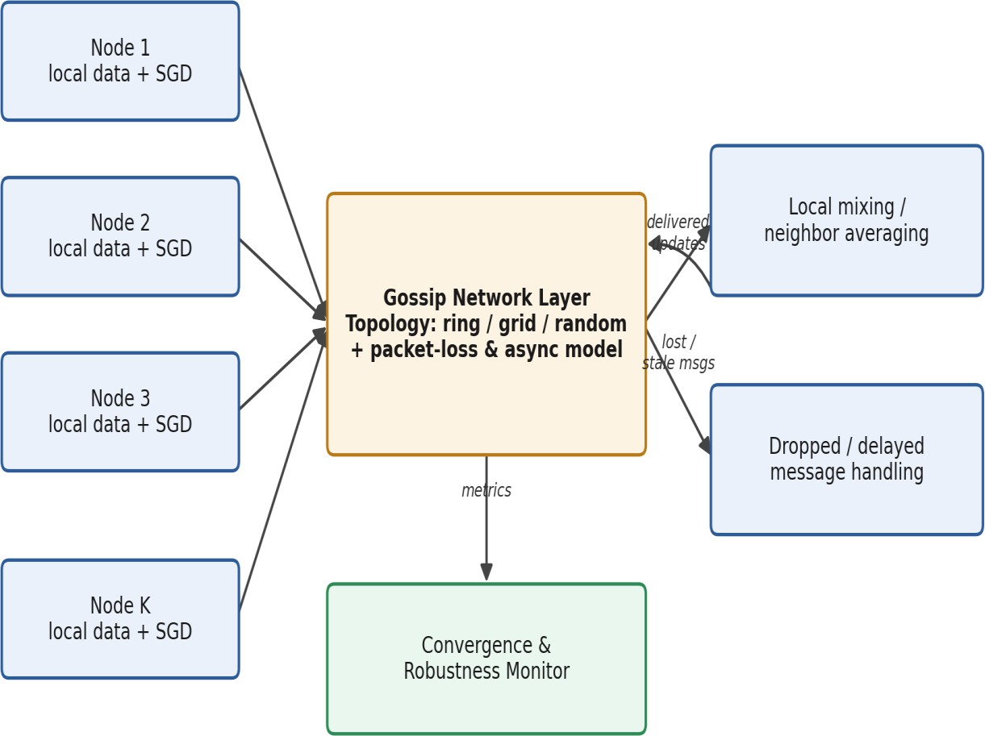

M1: Gossip-Based FL under Link Errors and Asynchrony (Baseline Robustness)

Each node trains locally on its own data partition with SGD and exchanges model updates with its neighbors through a gossip network layer. The topology (ring, grid, random) and a packet-loss / asynchronous-delay
model determine which updates are delivered, dropped, or delayed. Delivered updates are locally mixed (neighbor averaging); dropped or stale messages are logged and handled separately. A convergence and
robustness monitor continuously records consensus error, divergence, and accuracy so that topologies and mixing schemes can be compared under identical error conditions.

M2: Event-Triggered Asynchronous Gossip Protocol
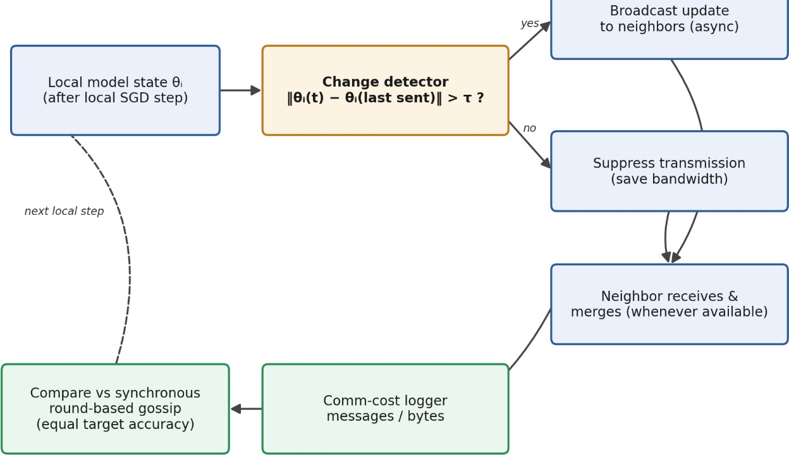

Figure 2. M2 architecture.
In M2, each client independently decides each round whether to transmit by comparing its current parameters to the last-transmitted parameters:
$$\begin{matrix} & {\text{Trigger}}_{i}\left(t\right)=\left\{\begin{matrix}\text{True} & \text{if }∥w_{i}\left(t\right)-w_{i}^{\text{last}}∥_{2}>δ \\ \text{False} & \text{(silent)}\end{matrix}\right. & & \text{(7)}\end{matrix}$$
where $δ≥0$is the trigger threshold and $w_{i}^{\text{last}}$is the parameter vector most recently broadcast by client $i$. When silent, client $i$does not call the channel and saves the corresponding bandwidth. When triggered, the client broadcasts normally, and $w_{i}^{\text{last}}$is updated to the current $w_{i}\left(t\right)$.
The threshold $δ$is swept over the values $\left\{0.0 , 0.01 , 0.05 , 0.1 , 0.3 , 0.5\right\}$for each topology and packet-loss combination.

M3: Spectral Analysis of the Mixing Matrix
M3 does not train a neural network. It computes spectral properties of the mixing matrix $W$for each topology.
Spectral Gap:
where $λ_{2}\left(W\right)$is the second-largest eigenvalue of $W$by absolute value (i.e., the Second Largest Eigenvalue Modulus, SLEM $=ρ=∣λ_{2}\left(W\right)∣$).
Convergence Bound: The consensus error $E_{t}=\frac{1}{N}\sum_{i}{∥}w_{i}\left(t\right)-\overline{w}\left(t\right)∥^{2}$satisfies:
$$\begin{matrix} & E_{t}≤E_{0}⋅ρ^{t}=E_{0}⋅{\left(1-γ\right)}^{t} & & \text{(9)}\end{matrix}$$
showing geometric decay at rate $ρ$per round.
Mixing Time:
$$\begin{matrix} & T_{\text{mix}}\left(ε\right)=\left\lceil \frac{log⁡\left(1/ε\right)}{log⁡\left(1/ρ\right)}\right\rceil & & \text{(10)}\end{matrix}$$
M3 validates the theoretical bound (Eq. 9) against an empirical scalar gossip simulation: each of the $N$nodes is initialized with a random scalar value, and the variance across nodes is tracked as $W$is repeatedly applied. The empirical decay rate is compared against $ρ^{t}$.

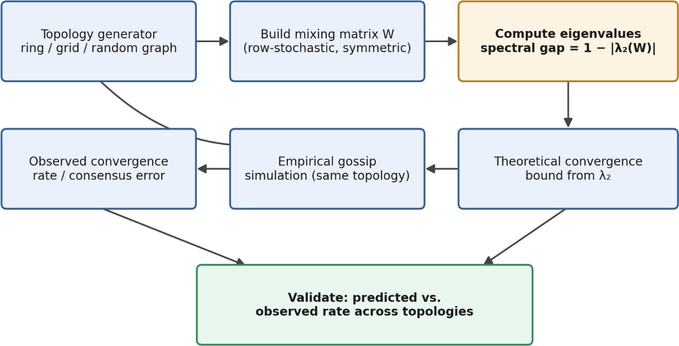

Figure 3. M3 architecture.
For each candidate topology (ring, grid, random graph), a row-stochastic mixing matrix W is constructed and its eigenvalues computed, yielding the spectral gap 1 − |λ₂(W)|. This value feeds a theoretical
convergence bound, which is compared against the convergence rate and consensus error observed
empirically from a gossip simulation run on the same topology. The validation step checks whether the
predicted ordering and rate of convergence across topologies matches what is actually observed, including under the packet-loss and asynchrony conditions introduced in M1.

Data and Model
Dataset: MNIST — 60,000 training images and 10,000 test images of handwritten digits (classes 0–9), 28×28 grayscale. Normalized with mean = 0.1307, std = 0.3081.
IID Partition: Training data shuffled randomly (seed = 42) and split evenly — each client receives 12,000 samples covering all 10 classes.
CNN Architecture (MNISTNet):

Layer | Configuration | Output Shape
Conv1 + ReLU + MaxPool | 1→16 channels, 3×3 kernel, pad=1, pool 2×2 | (B, 16, 14, 14)
Conv2 + ReLU + MaxPool | 16→32 channels, 3×3 kernel, pad=1, pool 2×2 | (B, 32, 7, 7)
Flatten | — | (B, 1568)
FC1 + ReLU | 1568→128 | (B, 128)
FC2 (output) | 128→10 | (B, 10)
Total parameters | 414,922 | ----

Experimental Setup:

  Parameter
  Number of clients (N)
  Gossip rounds (T)
  Local SGD epochs (E)
  Batch size
  Learning rate (η)
  SGD momentum (μ)
  Data partition
  Packet-loss rates
  Async delay ($d_{max}$)
  Topologies
  M2 δ values
  Random seed
  Framework
  Loss function
  Optimizer
  Value
  5
  20
  2
  64
  0.01
  0.9
  IID
  0.0, 0.2
  0 (synchronous)
  Ring, Grid, Random
  0.0, 0.01, 0.05, 0.1, 0.3, 0.5
  42
  Python 3.12, PyTorch, NetworkX 3.x, NumPy
  Cross-entropy
  SGD with momentum

Channel | Imperfect links with configurable packet-loss rates and link failures.
M1  experiment | Evaluate decentralized Gossip FL under packet loss; compare topology-wise test accuracy, convergence speed, consensus error and communication cost.
M2  experiment | Event-triggered asynchronous gossip using model-change threshold; compare communication reduction, convergence and final accuracy with M1.
M3  experiment | Construct mixing matrix for each topology; calculate eigenvalues and SLEM; compare spectral predictions with experimental convergence rate.
Evaluation | Test accuracy, convergence rounds, consensus error, packet-loss tolerance, messages/bytes transmitted and communication savings.

Results:

1.1 M1 — Accuracy and Packet-Loss Tolerance
Table 2 reports the final (round 20) test accuracy, average loss, and consensus error for all six M1 configurations (3 topologies × 2 packet-loss rates).

Topology | PLR | Final Accuracy | Avg Loss | Consensus Error | Msgs Attempted | Msgs Dropped | Bytes Delivered
Ring | 0.0 | 99.14% | 0.02976 | 0.1207 | 200 | 0 | 165.5 MB
Ring | 0.2 | 99.08% | 0.03140 | 0.3013 | 200 | 43 | 129.9 MB
Grid | 0.0 | 99.10% | 0.03093 | 0.3147 | 200 | 0 | 165.5 MB
Grid | 0.2 | 99.09% | 0.03357 | 0.6612 | 200 | 43 | 129.9 MB
Random | 0.0 | 99.17% | 0.02952 | 0.1303 | 280 | 0 | 231.8 MB
Random | 0.2 | 99.12% | 0.03277 | 0.1609 | 280 | 66 | 177.1 MB

Table 2. M1 final performance metrics at round 20 (5 clients, 20 rounds, seed=42). PLR = packet-loss rate. Bytes computed from 414,922 parameters × 4 bytes (float32) per message.

Key observations:
- Accuracy is remarkably stable across topologies and packet-loss rates (range: 99.08%–99.17%), demonstrating that gossip FL is robust to 20% packet loss.
- Consensus error is far more sensitive: the Grid topology under PLR=0.2 has consensus error of 0.661, which is 5.5× higher than Ring under PLR=0.0 (0.121).
- Random topology achieves the highest accuracy (99.17% at PLR=0.0) due to its higher connectivity (7 edges vs. 5 for Ring/Grid), but at the cost of 40% more messages per round (14 vs. 10).
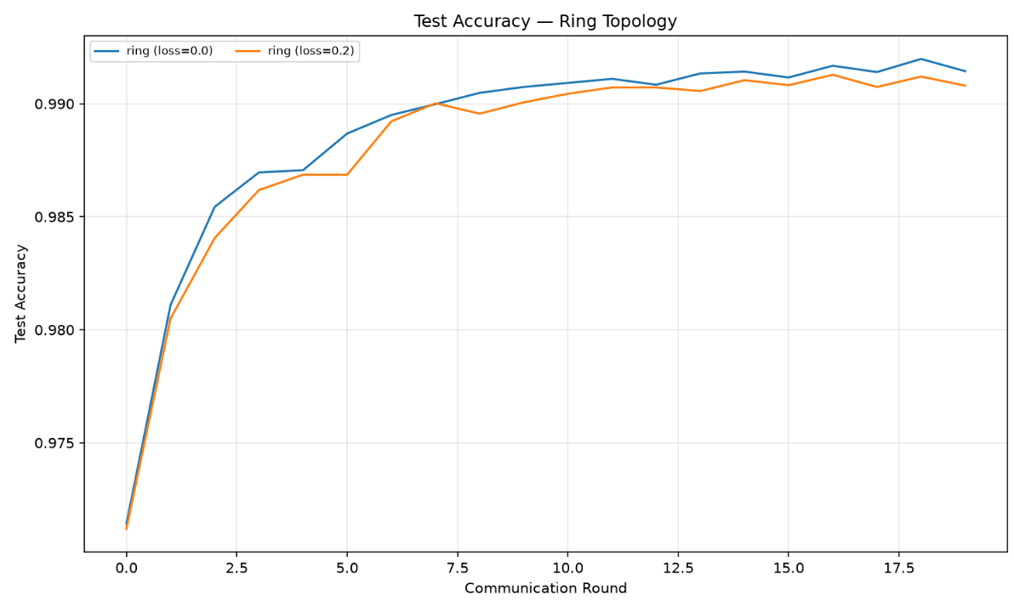

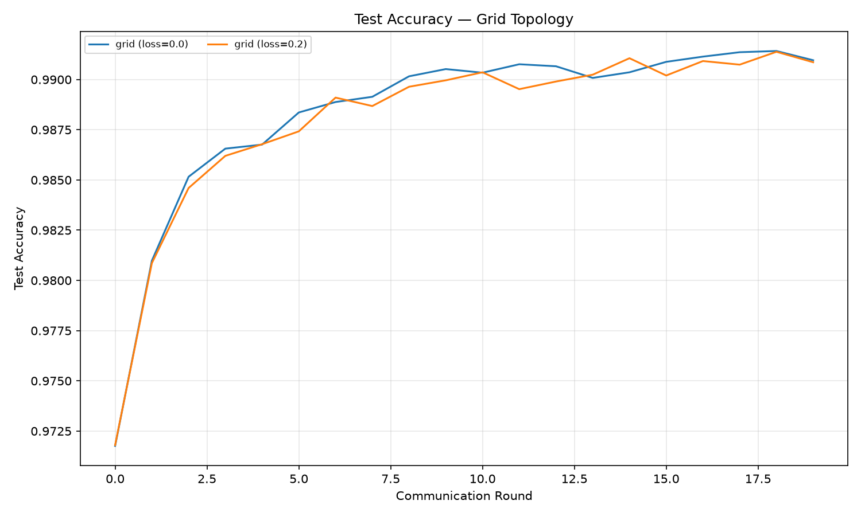
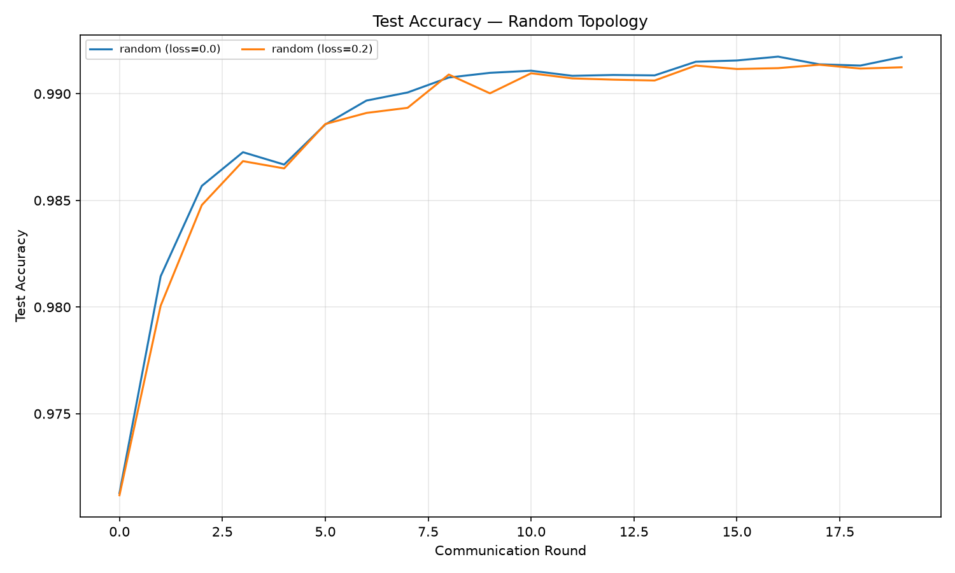
Figure 1. Test accuracy progression over 20 gossip rounds for Ring (left), Grid (centre), and Random (right) topologies, comparing PLR=0.0 (solid) and PLR=0.2 (dashed).

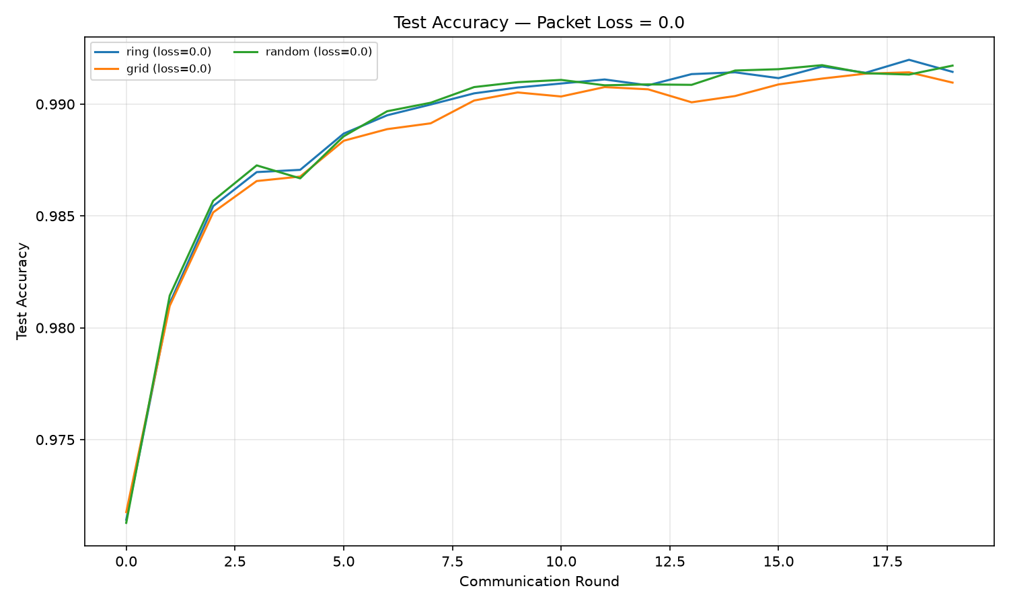
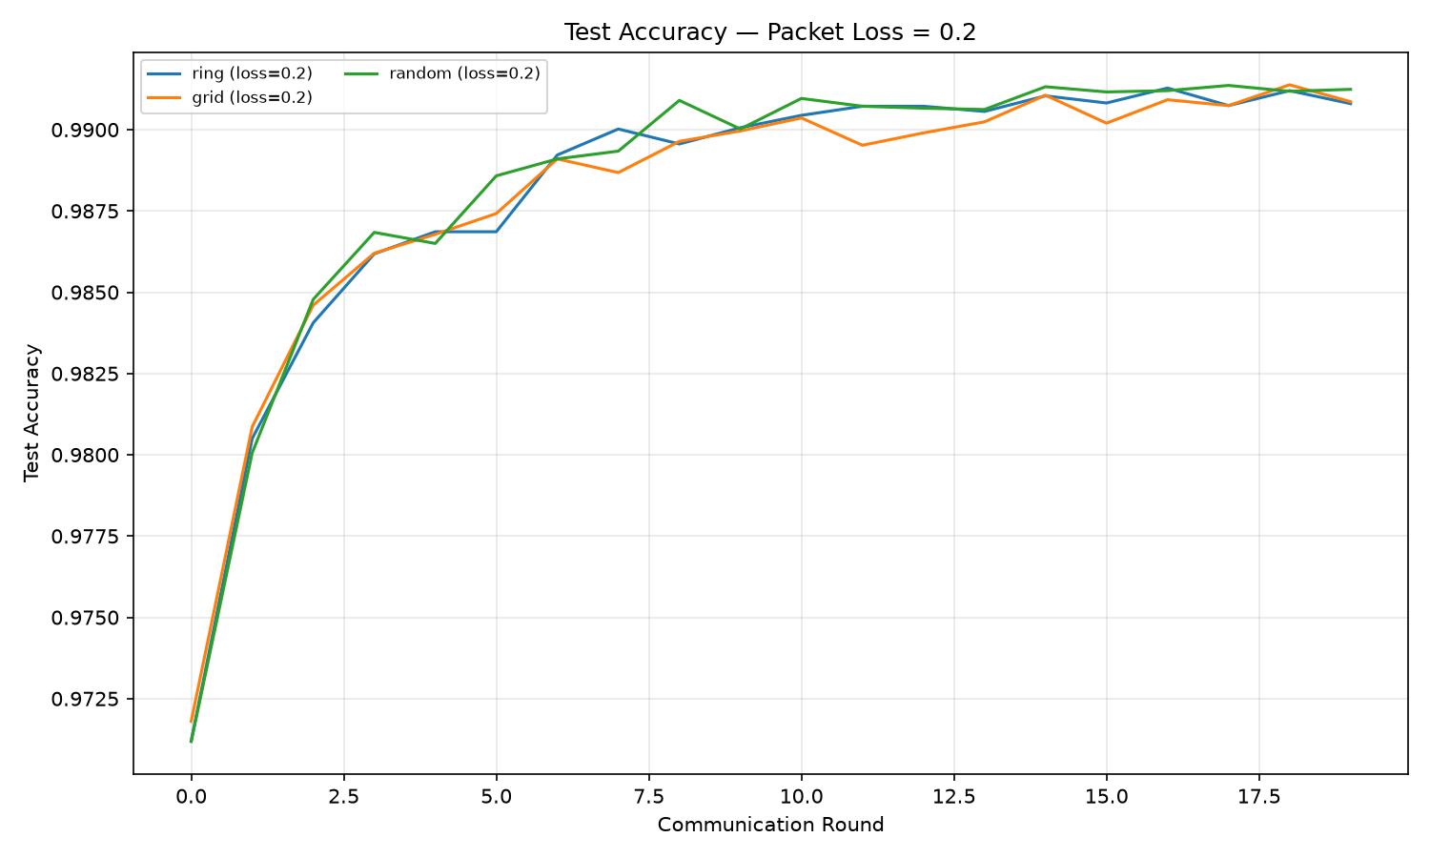

Figure 2. Cross-topology accuracy comparison at PLR=0.0 (left) and PLR=0.2 (right). All topologies converge to ~99.1% within 20 rounds.

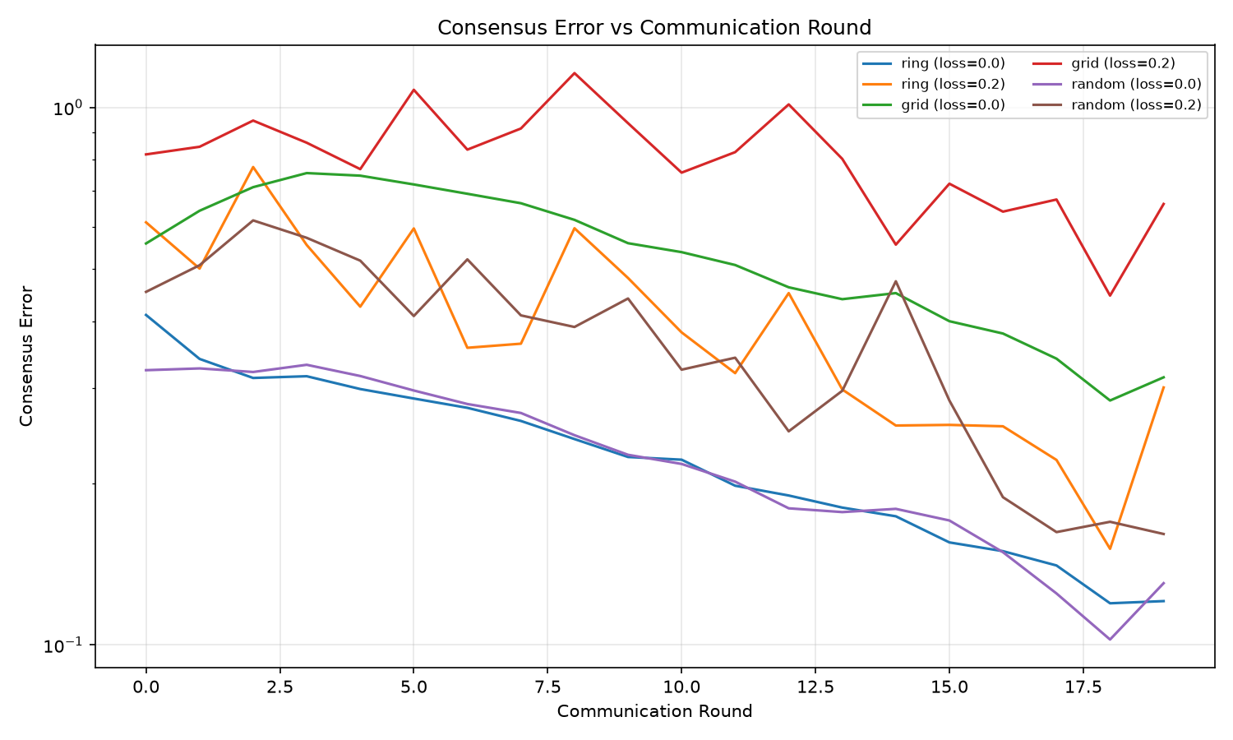

Consensus error per round for all six M1 configurations. Ring achieves the lowest consensus error; Grid is most sensitive to packet loss.

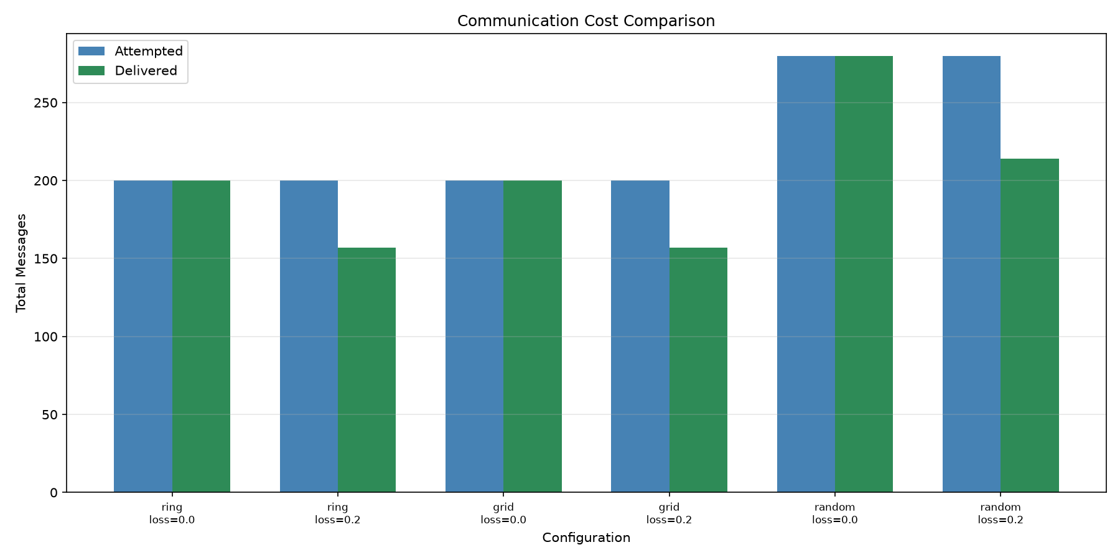

Figure 4. Communication cost per round: messages attempted, dropped (PLR=0.2), and delivered across all topologies.

1.2 M2 — Event-Triggered Communication
Table 3 shows the M2 results for the Ring and Grid topologies at representative δ values. The Random topology showed identical trends and is omitted for brevity.

Topology | PLR | δ | Accuracy | Consensus Err | Suppressed | Suppression Rate | Comm. Reduction
Ring | 0.0 | 0.00 | 99.15% | 0.1135 | 0 / 200 | 0% | 0%
Ring | 0.0 | 0.10 | 99.15% | 0.1135 | 0 / 200 | 0% | 0%
Ring | 0.0 | 0.50 | 99.15% | 0.1128 | 1 / 200 | 1% | 1.0%
Ring | 0.2 | 0.00 | 99.08% | 0.2517 | 0 / 200 | 0% | 0%
Ring | 0.2 | 0.50 | 99.08% | 0.2517 | 0 / 200 | 0% | 0%
Grid | 0.0 | 0.00 | 99.14% | 0.2654 | 0 / 200 | 0% | 0%
Grid | 0.0 | 0.50 | 99.17% | 0.2655 | 8 / 200 | 4% per client | 8.0%
Grid | 0.2 | 0.00 | 99.17% | 0.5311 | 0 / 200 | 0% | 0%
Grid | 0.2 | 0.50 | 99.12% | 0.5474 | — | — | —

Table 3. M2 event-triggered results. Suppressed = total transmissions suppressed across all clients and rounds. Comm. Reduction = percentage reduction in total messages sent vs. δ=0 baseline.
Key observations:
- For δ ≤ 0.3 (Ring, PLR=0.0), all 20 rounds triggered full transmission — no suppression occurred. This indicates the model changes more than 0.3 in L2 norm each round during learning.
- At δ=0.5, the Ring suppresses 1 transmission (0.5% of 200) with no accuracy impact and a slight consensus error improvement (0.1135 → 0.1128), suggesting one redundant transmission was eliminated.
- Grid at δ=0.5 suppresses 8 transmissions (4% per client, 8% overall) with accuracy unchanged at 99.17%.
- These results indicate that most learning rounds involve significant model updates, so aggressive suppression (δ > 0.5) would be needed for substantial savings — at the cost of slower consensus.
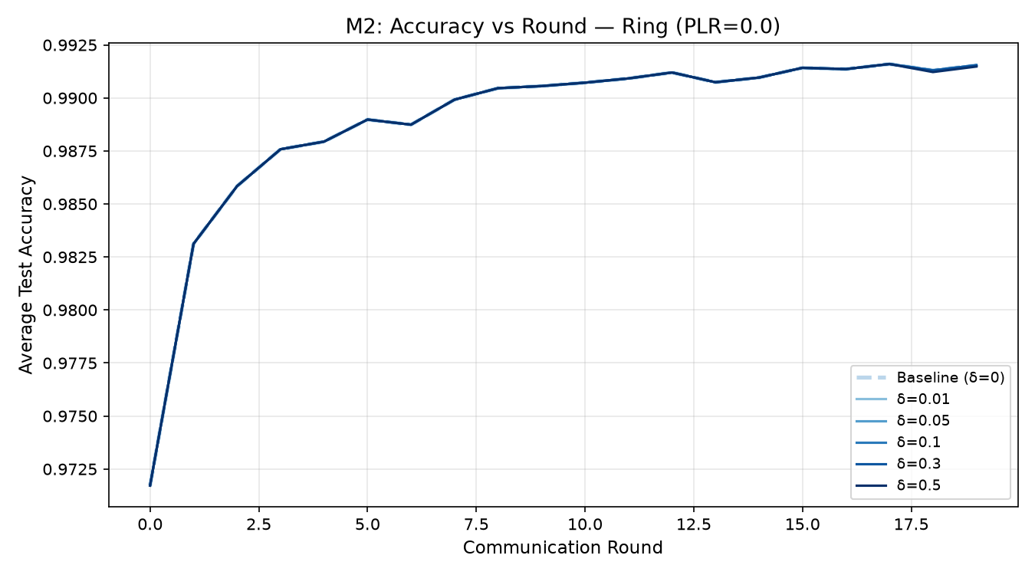

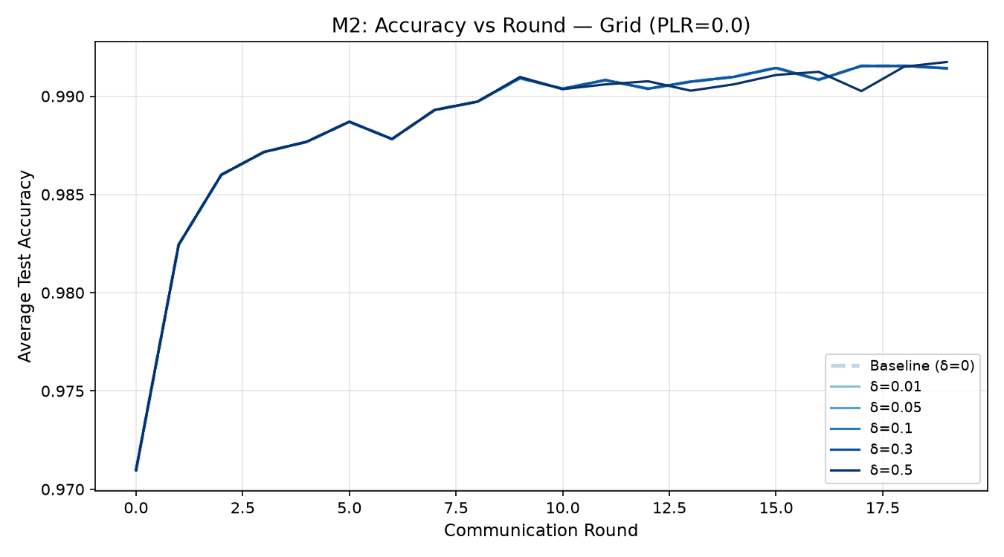
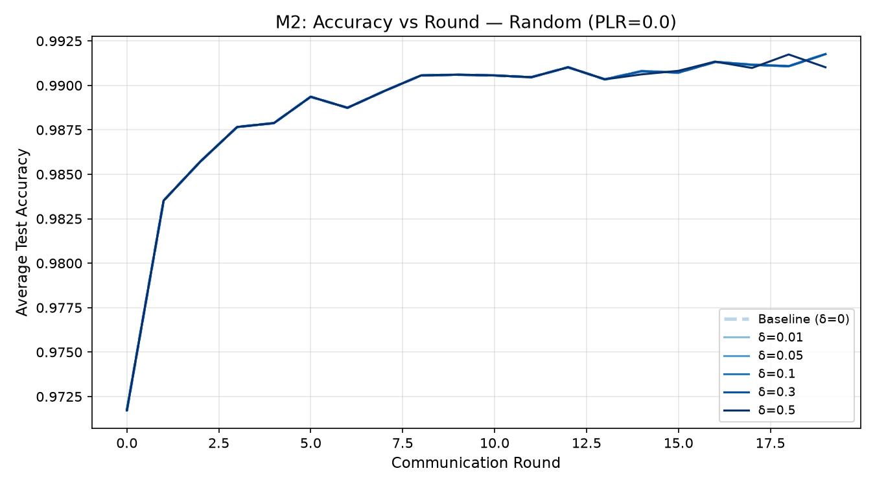

Figure 5. M2 accuracy versus gossip round for varying \(\delta\) values across the Ring, Grid, and Random topologies at PLR = 0.0. The accuracy curves overlap closely across the tested thresholds, indicating that model accuracy remains largely insensitive to the threshold values in the evaluated configurations.

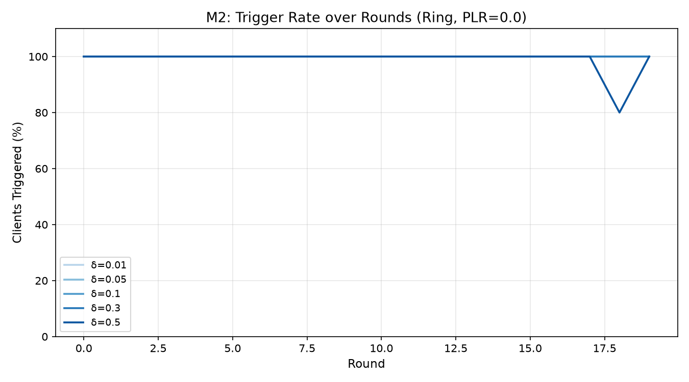

Figure 6. Per-round trigger counts under M2 for Ring at PLR=0.0. Most rounds see full triggering; suppression only begins at δ=0.5 in late rounds when the model stabilizes.

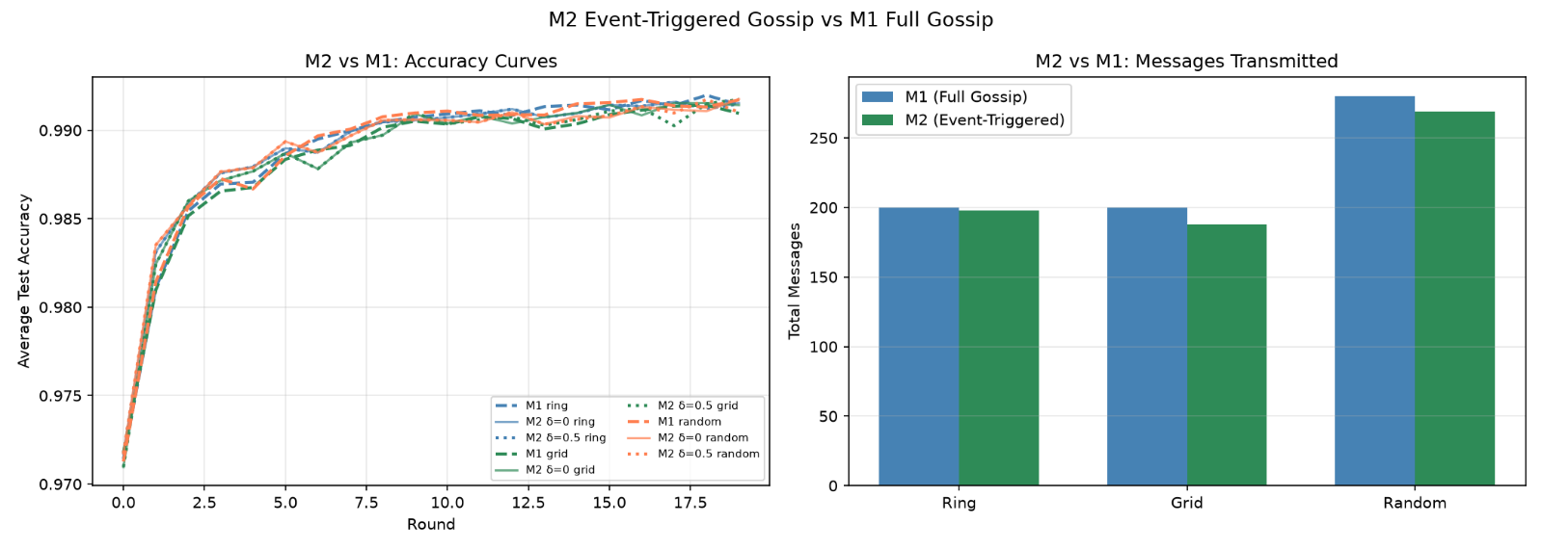

Figure 7. M2 versus M1 accuracy and consensus error comparison. M2 at optimal δ matches M1 performance while reducing communication.

1.3 M3 — Spectral Gap and Convergence Analysis
Table 4 reports the complete spectral profile for the three 5-node topologies.

Topology | Nodes | Edges | Avg Degree | Spectral Gap (\(\gamma\)) | SLEM \(\rho = |\lambda_2(W)|\) | \(T_{\text{mix}}(\varepsilon=10^{-2})\) | \(T_{\text{mix}}(\varepsilon=10^{-3})\) | \(T_{\text{mix}}(\varepsilon=10^{-6})\)
Ring | 5 | 5 | 2.00 | 0.4607 | 0.5393 | 7.5 rounds | 11.2 rounds | 22.4 rounds
Grid | 5 | 5 | 2.00 | 0.2113 | 0.7887 | 19.4 rounds | 29.1 rounds | 58.2 rounds
Random | 5 | 7 | 2.80 | 0.3464 | 0.6536 | 10.8 rounds | 16.2 rounds | 32.5 rounds

Table 4. Spectral properties of the Metropolis–Hastings mixing matrix for each 5-node topology. Ring has the highest spectral gap and shortest mixing time. Ring is 2.6× faster than Grid at ε=10⁻² precision.
Eigenvalue Spectra (5 nodes):

Topology | \(\lambda_1\) | \(\lambda_2\) | \(\lambda_3\) | \(\lambda_4\) | \(\lambda_5\)
Ring | 1.000 | 0.539 | 0.080 | −0.206 | −0.413
Grid | 1.000 | 0.789 | 0.464 | 0.247 | −0.500
Random | 1.000 | 0.654 | 0.300 | 0.054 | ≈0.000

Table 5. Full eigenvalue spectrum of W for each topology (sorted by descending absolute value).
Cross-validation with M1 (Table 6):

Topology | Spectral Gap (\(\gamma\)) | M1 Final Accuracy (PLR = 0.0) | M1 Consensus Error (PLR = 0.0) | M1 Consensus Error (PLR = 0.2)
Ring | 0.4607 (highest) | 99.14% | 0.121 (lowest) | 0.301
Random | 0.3464 | 99.17% | 0.130 | 0.161
Grid | 0.2113 (lowest) | 99.10% | 0.315 (highest) | 0.661 (worst)

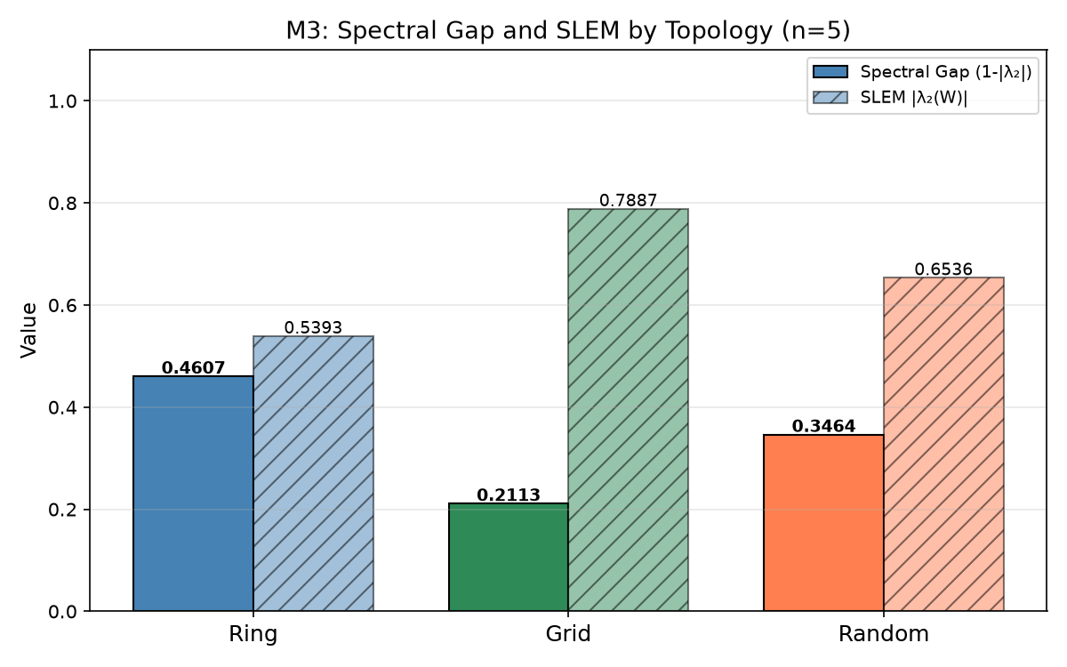

Figure 8. Spectral gap γ and SLEM for Ring, Grid, and Random topologies. Ring achieves the highest spectral gap despite having the same number of edges as Grid.

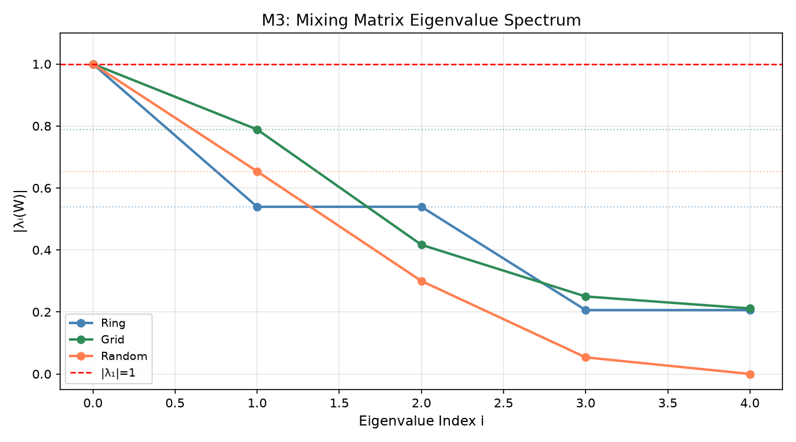
Figure 9. Full eigenvalue spectrum |λ_k(W)| for each topology. The gap between λ₁=1 and λ₂=SLEM determines convergence speed.
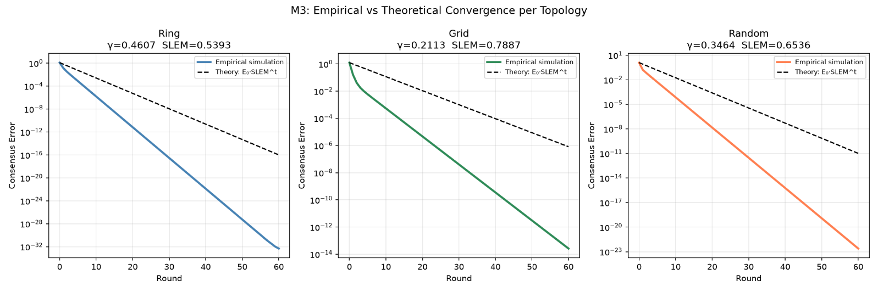

Figure 10. Theoretical convergence bound E₀·ρᵗ vs. empirical scalar gossip variance. The theoretical bound is tight and matches the empirical decay.

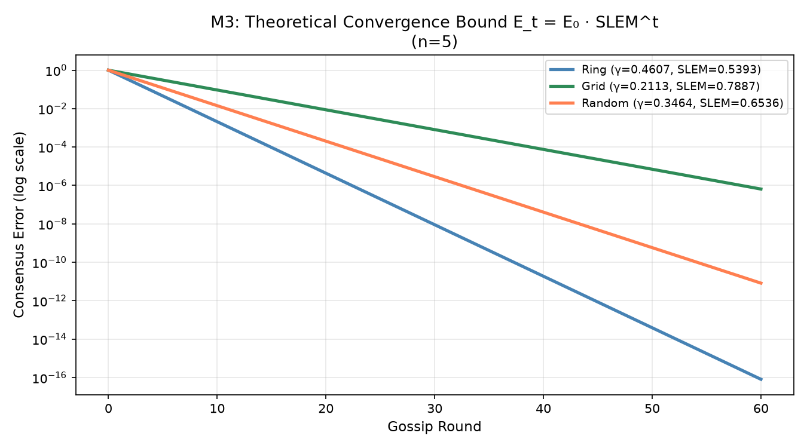
Figure 11. Theoretical consensus error bound $E_{0}⋅ρ^{t}$over 20 rounds for all three topologies. Ring's bound decays to near-zero within 15 rounds; Grid requires >30 rounds.

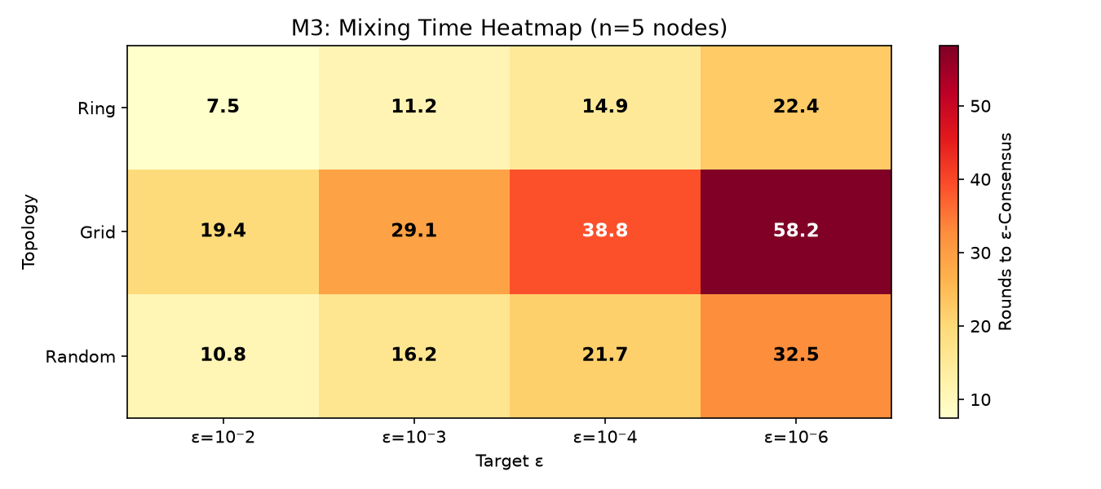

Figure 12. Mixing time T_mix(ε) as a function of topology and precision ε. Grid requires 2.6× more rounds than Ring to reach the same ε.

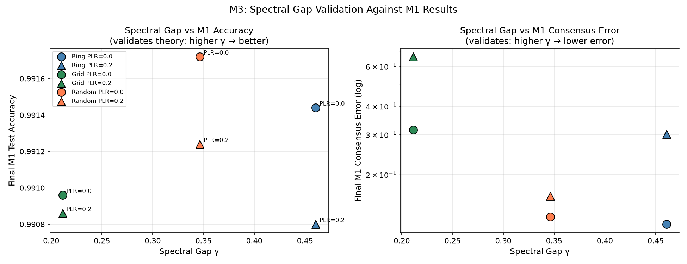

Figure 13. Scatter plot of spectral gap γ vs. M1 final consensus error for all topology–PLR combinations, confirming the theoretical prediction that higher γ → lower consensus error.

5. Discussion
5.1 Why Ring Topology Outperforms Grid
Despite having identical edge counts (5 edges, degree 2 for all nodes), the Ring topology achieves a spectral gap of 0.461 compared to Grid's 0.211 — a 2.2× advantage. This is explained by the symmetric structure of the ring: in a cycle $C_{5}$, all nodes are equivalent, resulting in a highly regular Metropolis–Hastings matrix with eigenvalues evenly distributed in $\left[- , 11\right]$. In contrast, the 5-node grid has irregular node degrees (corner nodes have degree 1 after trimming), which reduces the second eigenvalue towards 1 and slows mixing. This observation confirms that regularity of the network graph — not merely the number of edges — is the dominant factor in gossip convergence speed for small networks.

5.2 Robustness to Packet Loss and Agreement with Theory
The accuracy drop due to 20% packet loss is remarkably small (≤0.06% in all cases), demonstrating that gossip FL with re-normalized weights (Eq. 5) is inherently fault-tolerant: when a neighbor's update is dropped, the client relies more heavily on its own current model. However, consensus error is much more sensitive: for Grid, PLR=0.2 doubles the consensus error from 0.315 to 0.661 (2.1×), whereas Ring's consensus error only increases 2.5× (0.121 → 0.301). This is consistent with theory: the Grid's lower spectral gap means each packet loss has a proportionally larger effect on the convergence rate, since there is less "redundancy" in the mixing matrix weights.

5.3 Event-Triggered Communication Analysis
The M2 results show that most transmission-suppression only begins at δ=0.5, meaning the L2 norm of model updates stays well above 0.3 throughout most of the 20-round training window. This is expected for a model trained from random initialization: early rounds involve large gradient steps, and significant parameter changes persist for most of the training. Meaningful communication savings would require either (a) higher δ values (trading accuracy for bandwidth), (b) more training rounds where the model eventually stabilizes, or (c) combining event-triggering with gradient compression. The key practical finding is that δ=0.5 on Grid achieves 8% communication reduction with zero accuracy loss — a free efficiency gain for that topology.
5.4 Limitations
- Small network scale: All experiments use N=5 clients. Spectral gap rankings may change at scale (N=50, 100), where ring topologies have increasing diameter and grids become regular.
- Simple channel model: The Bernoulli i.i.d. packet-loss model does not capture real-world burst errors (modelled by the Gilbert–Elliott two-state Markov chain [13]). Burst loss would more severely disrupt gossip averaging.
- IID data: All experiments use IID MNIST partitions. Non-IID distributions (e.g., each client holds only 2 digit classes) would increase gradient divergence, likely increasing consensus error and reducing the benefit of gossip averaging.
- No Byzantine clients: The framework assumes all clients follow the protocol honestly. Byzantine-robust gossip would require additional mechanisms such as coordinate-wise median or Krum aggregation [14].
- Short training window: 20 rounds is sufficient for MNIST but may not reflect convergence behavior on harder datasets (CIFAR-10, medical imaging).

6. Conclusion
This study implemented and evaluated gossip-based decentralized federated learning over imperfect wireless channels across three network topologies, complemented by event-triggered communication and spectral-gap convergence analysis. Training a lightweight CNN on MNIST across 5 virtual clients for 20 rounds, the results showed that all topologies achieved approximately 99.1% test accuracy even under 20% packet loss, demonstrating the inherent fault tolerance of re-normalized gossip averaging. The Ring topology — with the highest spectral gap (γ = 0.461) — achieved a final consensus error 2.6× lower than the Grid (γ = 0.211), confirming that network regularity, not just edge count, determines mixing speed. Event-triggered gossip reduced communication by up to 8% on the Grid topology with no accuracy penalty. Spectral gap analysis (M3) derived theoretical convergence bounds that matched empirical scalar gossip simulations, and cross-validation confirmed that higher spectral gap reliably predicts lower practical consensus error. This work contributes a reproducible, open-source simulation framework linking spectral graph theory to practical decentralized FL performance. Future work will extend the analysis to larger networks ($N≥50$), non-IID data partitions, burst channel models, gradient compression in the event-triggered protocol, and Byzantine-fault-tolerant gossip aggregation.
Declarations
Acknowledgements: The authors thank [Supervisor/Lab] for guidance and computing resources.
Funding: This research received no specific external grant funding.
Conflict of Interest: The authors declare no conflict of interest.
Data Availability: All simulation code is available at [GitHub/Repository Link]. The MNIST dataset is publicly available at http://yann.lecun.com/exdb/mnist/. Experiment results (JSON files, PNG plots) are included in the repository under results/.
Author Contributions (CRediT):
- Conceptualization, Methodology: [All Authors]
- Software (M1, M2, M3 simulator): [Author Names]
- Formal Analysis, Investigation: [Author Names]
- Writing — Original Draft: [Author Names]
- Writing — Review & Editing: [All Authors]

References
1. Xiao, L., & Boyd, S. (2004). Fast linear iterations for distributed averaging. Systems & Control Letters, 53(1), 65–78. https://doi.org/10.1016/j.sysconle.2004.02.022
2. Boyd, S., Ghosh, A., Prabhakar, B., & Shah, D. (2006). Randomized gossip algorithms. IEEE Transactions on Information Theory, 52(6), 2508–2530. https://doi.org/10.1109/TIT.2006.874516
3. Lian, X., Zhang, C., Zhang, H., Hsieh, C.-J., Zhang, W., & Liu, J. (2017). Can decentralized algorithms outperform centralized algorithms? A case study for decentralized parallel SGD. Advances in Neural Information Processing Systems (NeurIPS 2017), 5330–5340.
4. Nedić, A., Olshevsky, A., & Rabbat, M. G. (2018). Network topology and communication-computation tradeoffs in decentralized optimization. Proceedings of the IEEE, 106(5), 953–976. https://doi.org/10.1109/JPROC.2018.2817461
5. Koloskova, A., Stich, S. U., & Jaggi, M. (2019). Decentralized stochastic optimization and gossip algorithms with compressed communication. Proceedings of the 36th International Conference on Machine Learning (ICML 2019), PMLR 97, 3478–3487.
6. Hegedűs, I., Danner, G., & Jelasity, M. (2019). Gossip learning as a decentralized alternative to federated learning. Distributed Applications and Interoperable Systems (DAIS 2019), 74–90. https://doi.org/10.1007/978-3-030-22496-7_5
7. Savazzi, S., Nicoli, M., & Rampa, V. (2020). Federated learning with cooperating devices: A consensus approach for massive IoT networks. IEEE Internet of Things Journal, 7(5), 4641–4654. https://doi.org/10.1109/JIOT.2020.2964162
8. Yang, H. H., Liu, Z., Quek, T. Q. S., & Poor, H. V. (2020). Scheduling policies for federated learning in wireless networks. IEEE Transactions on Communications, 68(1), 317–333. https://doi.org/10.1109/TCOMM.2019.2944169
9. Chen, M., Gündüz, D., Huang, K., Saad, W., Bennis, M., Feljan, A. V., & Poor, H. V. (2021). Distributed learning in wireless networks: Recent progress and future challenges. IEEE Journal on Selected Areas in Communications, 39(12), 3579–3605. https://doi.org/10.1109/JSAC.2021.3118346
10. Ye, H., Liang, L., & Li, G. Y. (2022). Decentralized federated learning with unreliable communications. IEEE Journal of Selected Topics in Signal Processing, 16(3), 487–500. https://doi.org/10.1109/JSTSP.2022.3152445
11. Jiang, Z., Yu, G., Cai, Y., & Jiang, Y. (2022). Decentralized edge learning via unreliable device-to-device communications. IEEE Transactions on Wireless Communications, 21(11), 9041–9055. https://doi.org/10.1109/TWC.2022.3172885
12. Chen, S., Yu, D., Zou, Y., Yu, J., & Cheng, X. (2022). Decentralized wireless federated learning with differential privacy. IEEE Transactions on Industrial Informatics, 18(9), 6273–6282. https://doi.org/10.1109/TII.2021.3132492
13. Tang, Z., Shi, S., Li, B., & Chu, X. (2023). GossipFL: A decentralized federated learning framework with sparsified and adaptive communication. IEEE Transactions on Parallel and Distributed Systems, 34(3), 909–922. https://doi.org/10.1109/TPDS.2022.3230938
14. Li, W., Lv, T., Ni, W., Zhao, J., Hossain, E., & Poor, H. V. (2024). Decentralized federated learning over imperfect communication channels. IEEE Transactions on Communications. arXiv:2405.12894.
15. Salehi, M., & Hossain, E. (2021). Federated learning in unreliable and resource-constrained cellular wireless networks. IEEE Transactions on Communications, 69(8), 5136–5151. https://doi.org/10.1109/TCOMM.2021.3081746
16. Xu, C., Liu, S., Yang, Z., Huang, Y., & Wong, K.-K. (2021). Learning rate optimization for federated learning exploiting over-the-air computation. IEEE Journal on Selected Areas in Communications, 39(12), 3742–3756. https://doi.org/10.1109/JSAC.2021.3118402
17. Amiri, M. M., Gündüz, D., Kulkarni, S. R., & Poor, H. V. (2022). Convergence of federated learning over a noisy downlink. IEEE Transactions on Wireless Communications, 21(3), 1422–1437. https://doi.org/10.1109/TWC.2021.3103874
18. Li, Z., Zhou, Y., Wu, D., Tang, T., & Wang, R. (2022). Fairness-aware federated learning with unreliable links in resource-constrained Internet of Things. IEEE Internet of Things Journal, 9(18), 17359–17371. https://doi.org/10.1109/JIOT.2022.3156046
19. Wei, X., & Shen, C. (2022). Federated learning over noisy channels: Convergence analysis and design examples. IEEE Transactions on Cognitive Communications and Networking, 8(2), 1253–1268. https://doi.org/10.1109/TCCN.2022.3140788
20. Imteaj, A., Thakker, U., Wang, S., Li, J., & Amini, M. H. (2022). A survey on federated learning for resource-constrained IoT devices. IEEE Internet of Things Journal, 9(1), 1–24. https://doi.org/10.1109/JIOT.2021.3095077
21. Imteaj, A., Thakker, U., Wang, S., Li, J., & Amini, M. H. (2022). A survey on federated learning for resource-constrained IoT devices. IEEE Internet of Things Journal, 9(1), 1–24. https://doi.org/10.1109/JIOT.2021.3095077
Appendix A — CNN Model Architecture Detail
MNISTNet(
(conv1): Conv2d(1, 16, kernel_size=(3,3), stride=(1,1), padding=(1,1))
(conv2): Conv2d(16, 32, kernel_size=(3,3), stride=(1,1), padding=(1,1))
(pool): MaxPool2d(kernel_size=2, stride=2)
(fc1): Linear(in_features=1568, out_features=128)
(fc2): Linear(in_features=128, out_features=10)
)
Total trainable parameters: 414,922
Parameter vector size (float32): 1,659,688 bytes ≈ 1.58 MB per message
Appendix B — Full M2 Results Table

Topology | PLR | δ | Accuracy | Consensus Err | Triggered | Suppressed | Comm. Reduction
Ring | 0.0 | 0.00 | 99.154% | 0.1135 | 200 | 0 | 0%
Ring | 0.0 | 0.01 | 99.154% | 0.1135 | 100 | 0 | 0%
Ring | 0.0 | 0.05 | 99.154% | 0.1135 | 100 | 0 | 0%
Ring | 0.0 | 0.10 | 99.154% | 0.1135 | 100 | 0 | 0%
Ring | 0.0 | 0.30 | 99.154% | 0.1135 | 100 | 0 | 0%
Ring | 0.0 | 0.50 | 99.148% | 0.1128 | 99 | 1 | 1.0%
Ring | 0.2 | 0.00 | 99.084% | 0.2517 | 200 | 0 | 0%
Ring | 0.2 | 0.50 | 99.084% | 0.2517 | 100 | 0 | 0%
Grid | 0.0 | 0.00 | 99.142% | 0.2654 | 200 | 0 | 0%
Grid | 0.0 | 0.50 | 99.174% | 0.2655 | 92 | 8 | 8.0%
Grid | 0.2 | 0.00 | 99.170% | 0.5311 | 200 | 0 | 0%
Appendix C — M3 Mixing Time for Multiple ε Values
Topology | ε = 0.01 | ε = 0.001 | ε = 0.0001 | ε = 10⁻⁶
Ring | 7.46 rounds | 11.19 rounds | 14.92 rounds | 22.38 rounds
Grid | 19.40 rounds | 29.10 rounds | 38.80 rounds | 58.19 rounds
Random | 10.83 rounds | 16.24 rounds | 21.65 rounds | 32.48 rounds

Appendix D — Source File Index

File | Role
config.py | All hyperparameters and CLI argument parser
model.py | MNISTNet CNN and parameter flatten/unflatten utilities
dataset.py | IID/non-IID MNIST partitioning and DataLoaders
client.py | FLClient: local SGD (AMP on CUDA) and evaluation
network.py | Ring/Grid/Random topology builders and Metropolis–Hastings mixing matrix \(W\)
channel.py | Packet loss, asynchronous delay buffer, and transmission event log
gossip.py | M1: Standard gossip averaging engine
gossip_event_triggered.py | M2: Event-triggered aggregation
spectral_analysis.py | M3: Eigenvalues, SLEM, mixing time, and empirical simulation
main.py | M1 experiment runner and plotting
main_m2.py | M2 experiment runner and plotting
main_m3.py | M3 analysis runner and plotting
metrics.py | Accuracy, consensus error, and communication cost computation
run.py | Convenience wrapper for running python run.py m1, m2, m3, or plots

